Bangladesh Medical Association (BMA)
List of Life Member-30
60. BMA Shariatpur Branch

Sl No | Voter No | Voter Details
1 | Voter No  LM-4100244  No Image | DR. MD. ZAKIR UDDIN  F/Name: Md. Sultan Uddin  M/Name:  BM & DC Reg. No:  NID:  Cell:  Address: DCH, Course, Mymenshing Medical College, Mymensingh  Blood Group:
2 | Voter No  LM-6000001  No Image | DR. NARAYAN PRASAD CHOWDHURY  F/Name:  M/Name:  BM & DC Reg. No:  NID:  Cell:  Address:  Blood Group:  TRANSFERED to BMA Dhaka City  LM-1405543
3 | Voter No  LM-6000002  No Image | DR. MD. MOSHARROF HOSSAIN  F/Name: Md. Abdul Latif Howlader  M/Name:  BM & DC Reg. No:  NID:  Cell:  Address: Medical Officer MCH-FP  Thana Health Complex  Bhedorgnoj  Shariatpur  Blood Group:
4 | Voter No  LM-6000003  No Image | DR. SYED ANWAR HOSSAIN  F/Name: Late Syed Fakhar Uddin Ahmed  M/Name:  BM & DC Reg. No:  NID:  Cell:  Address: Medical Officer  Thana Health Complex  Damudda  Shariatpur  Blood Group:
5 | Voter No  LM-6000004  No Image | DR. MD. ZAKIR UDDIN  F/Name:  M/Name:  BM & DC Reg. No:  NID:  Cell:  Address:  Blood Group:  TRANSFERED to BMA Dhaka City  LM-1405543
6 | Voter No  LM-6000005  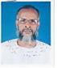 | DR. A.K.M ENAMUL HOQUE  F/Name: Md. Hassan Ali  M/Name:  BM & DC Reg. No:  NID:  Cell:  Address: Thana Health Complex  Naria  Shariatpur  Blood Group:
7 | Voter No  LM-6000006  No Image | DR. MD. ABDUL JABBER HOWLADER  F/Name:  M/Name:  BM & DC Reg. No:  NID:  Cell:  Address:  Blood Group:  TRANSFERED to BMA Dhaka City  LM-1405543
8 | Voter No  LM-6000007 | DR. ABDUL BARI  F/Name: Late. Abdul Aziz Mollah  M/Name: Late. Zaheda Khatun  BM & DC Reg. No: 5366  NID: 8626901104739  Cell: 01823762555  Address: Uttar Palong, Palong School Street, Shariatpur  Blood Group: O+
9 | Voter No  LM-6000009  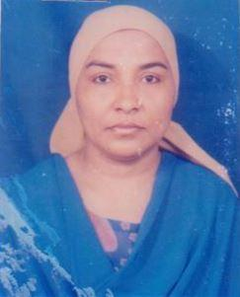 | DR. HOSHNE- ARA- BEGUM  F/Name: Md. Abul Hashem Khan  M/Name:  BM & DC Reg. No: 23294  NID:  Cell:  Address: Junior Consultant Gyaeny,  Health Complex, Damudda,  Shariatpur.  Blood Group:
10 | Voter No  LM-6000010 | DR. SHEIKH MOHAMMAD MOSTAFA  F/Name: Matiur Rahman Shekh  M/Name: Amena Begum  BM & DC Reg. No: 52576  NID: 8626905118750  Cell: 01720681328  Address: Vill: Uttar Baluchar, P.S: Palong, P.O: Shariatpur Sadar, Dist: Shariatpur  Blood Group: A-
11 | Voter No  LM-6000011  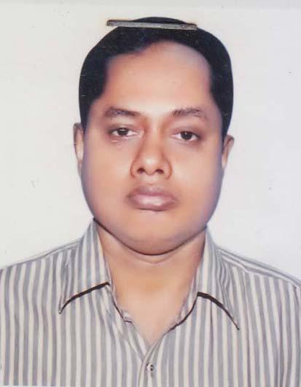 | DR. AKUL KRISHNA KARMAKAR  F/Name: Late- Surendra Chandra Karmakar  M/Name: Late- Usha Rani Karmakar  BM & DC Reg. No: 16737  NID: 8616537280570  Cell: 01715033484  Address: Vill. Parditsar, PO. Parditsar, P.s- Makr, Dist- Shariatpur  Blood Group: AB+
12 | Voter No  LM-6000012 | DR. RAJESH MAJUMDER  F/Name: Mr. Makunda Lal Majumdar  M/Name: Mrs. Bela Majumdar  BM & DC Reg. No: 30549  NID: 8626904110464  Cell: 01714223820  Address: Sadar Upazella Health Complex, Shariatpur  Blood Group: O+
13 | Voter No  LM-6000013  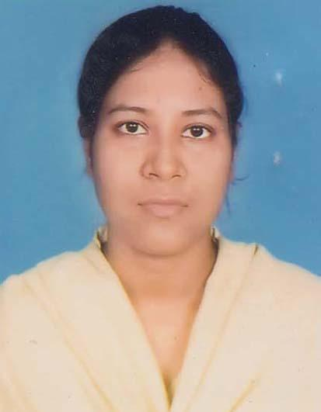 | DR. SHAILA PARVEEN  F/Name: Kutub Uddin Ahmed  M/Name: Nazma Begum  BM & DC Reg. No: 49921  NID:  Cell: 01678009271  Address: Sadar, Shariatpur Hospital  Blood Group: A+
14 | Voter No  LM-6000014 | DR. RAFIQUL ISLAM MAMUN  F/Name: Idris Ali Sarder  M/Name: Nargis Akter  BM & DC Reg. No: 43223  NID: 8626909129943  Cell: 01923493953  Address: Vill: Kashavoge, Post: Angaria Sadar, Shariatpur  Blood Group: O+
15 | Voter No  LM-6000015 | DR. SUMON KUMAR PODDER  F/Name: Shanti Ranjan Podder  M/Name: Shafali Rani Podder  BM & DC Reg. No: 48824  NID: 8626909127760  Cell: 01715820555  Address: Radiologist, Sadar Hospital, Shariatpur  Blood Group: O+
16 | Voter No  LM-6000016 | DR. MAHMUDUL HASAN  F/Name: Late. Arab Ali Sardar  M/Name: Mrs. Azufa Khatun  BM & DC Reg. No: 44502  NID: 19792611038861424  Cell: 01716131471  Address: Sadar Hospital, Shariatpur  Blood Group: B+
17 | Voter No  LM-6000017  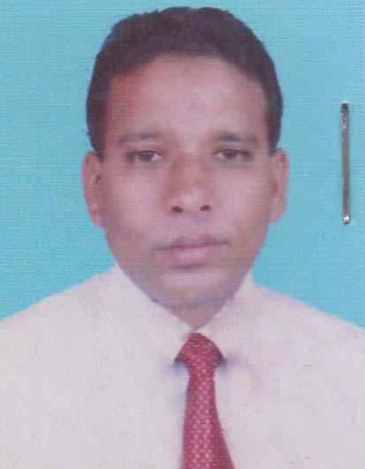 | DR. MOHAMMAD AKRAM ALAHI  F/Name: Mohammad Rokonuddin Mollah  M/Name: Wahidun Nesa  BM & DC Reg. No: 34064  NID: 2695421014733  Cell: 01191329176  Address: Sadar Hospital, Shariatpur  Blood Group: B+
18 | Voter No  LM-6000018 | DR. KHALED SHAWKAT ALI  F/Name: Col (retd.) Shawkat Ali, Mp  M/Name: Majeda Shawkat Ali  BM & DC Reg. No: 23046  NID: 1967862650125506  Cell: 01755577589  Address: Residence of Honorable Deputy Speaker. Dhaka.  Blood Group: B+
19 | Voter No  LM-6000019  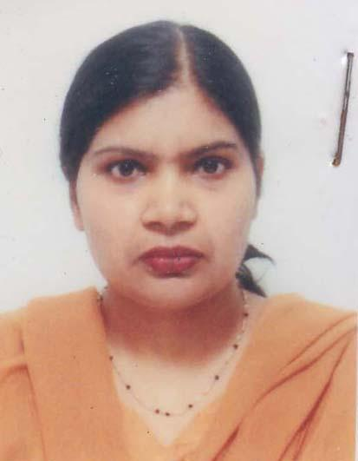 | DR. TANINA KHALEDA ALI  F/Name: A. Kaja Mohiuddin  M/Name: Ayesha Beevi  BM & DC Reg. No: 23047  NID: 19678626501257507  Cell: 01753552556  Address: Residence of Honorable. Deputy Speaker, Sher-e-Bangla Nagar, Bangladesh Parliament, Dhaka.  Blood Group: B+
20 | Voter No  LM-6000020  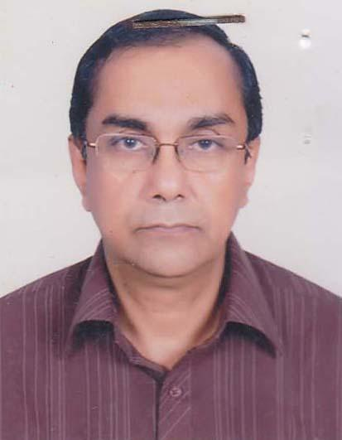 | DR. MD. GOLAM FARUQUE  F/Name: Late Dr. Golam Mawla  M/Name: Late. Fatema Khatun  BM & DC Reg. No: 13750  NID: 8616569414981  Cell: 01715108412  Address: Vill- Poragacha, Post & Thana- Noria, Dist: Shariatpur  Blood Group: A+
21 | Voter No  LM-6000021 | DR. MONIRUL ISLAM  F/Name: Omar Ali  M/Name: Mazeda Begum  BM & DC Reg. No: 41758  NID: 8626909125469  Cell: 01711264995  Address: Pathologist, Sadar Hospital, Shariatpur  Blood Group: B+
22 | Voter No  LM-6000022  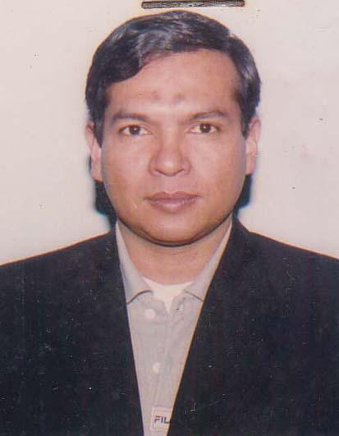 | DR. MD. SHAFIQUR RAHMAN  F/Name: Md. Siddiqur Rahman  M/Name: Mrs. Rahima Begum  BM & DC Reg. No: 23871  NID:  Cell: 01715012039  Address: Rahima Eye Hospital, 96 Shahid Faruk Road, Zatrabari, Dhaka  Blood Group: A+
23 | Voter No  LM-6000023 | DR. SYEDA SHAHINUR  F/Name: Syed Nur Mohammad  M/Name: Mrs. Asma Parveen  BM & DC Reg. No: 34656  NID:  Cell: 01928259055  Address: Panichaltna, Madaripur Intrent  Or Al Jabin School, Shariatpur  Blood Group:
24 | Voter No  LM-6000024 | DR. MD. HARUN-OR-RASHID  F/Name: Md. Moazzem Hossain  M/Name: Zahanara Hossain  BM & DC Reg. No: 48218  NID: 8622508517374  Cell: 01911679307  Address: South Damudya, PO & PS- Damudya, Dist- Shariatpur.  Blood Group: B+
25 | Voter No  LM-6000025  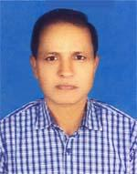 | DR. NIRMOL CHANDRA DAS.  F/Name: Late Jogendra Chandra Das.  M/Name: Late. Kumodini Das.  BM & DC Reg. No: 16253  NID: 1911863675414  Cell: 01711445912  Address: Upazilla Health & Family Planing Officer, Shariatpur.  Blood Group: O+
26 | Voter No  LM-6000026  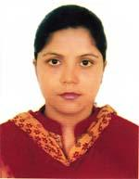 | DR. MITU AKTER.  F/Name: Md. Shahjahan Modbar  M/Name: Samsunnahar  BM & DC Reg. No: 60003  NID: 1916765152616  Cell: 01789019697  Address: NASIA, SHARIATPUR  Blood Group: A+
27 | Voter No  LM-6000027  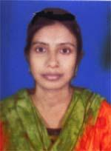 | DR .AMBIA BEGUM  F/Name: Nazrul Islam.  M/Name: Rasheda Begum  BM & DC Reg. No: 52230  NID: 0695112193372  Cell: 01726600142  Address: HOSPITAL QUATEL JADOR SADAR, SHARAATPUR.  Blood Group: B+
28 | Voter No  LM-6000028 | DR MOHAMMAD BADSHA MIAH  F/Name: Nashed Ali Syal .  M/Name: Begum Fazilatunnessa  BM & DC Reg. No: 31658  NID: 2696352206456  Cell: 01715469729  Address: shariatpur,  Blood Group: B+
29 | Voter No  LM-6000029  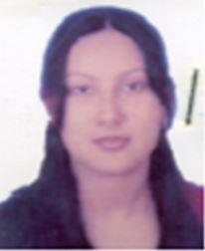 | DR. SABRINA KHAN .  F/Name: K.m. Didarul Islam  M/Name: Arefa Sultana  BM & DC Reg. No: 49752  NID: 919620313413  Cell: 01712297421  Address: DOCTOR; DORMITORY SADAR HOSOITAL SHARIATPUR.  Blood Group: B+
30 | Voter No  LM-6000030 | DR. MAHMUDUL HASAN  F/Name: B.m. Yousuf Ali  M/Name: Nurun Nahar  BM & DC Reg. No: 88597  NID: 3264817101  Cell: 01715998815  Address: Vill: Atong, PO: Burirhate, PS: Palong, Dist: Shariatpur.  Blood Group: B+

